NEW CONCEPTS FOR HIGH-POWER-DENSITY ENERGY EXTRACTION SYSTEMS

Nasr M. Ghoniem

Mechanical and Aerospace Engineering Department
University of California, Los Angeles (UCLA)
Los Angeles, CA. 90095-1600

APEX Meeting
UCLA

January 12, 1998

OUTLINE

1. LIMITATIONS OF PRESENT CONCEPTS 2
2. STRUCTURAL FOAM / EVAPORATIVE LIQUID SYSTEMS 3
3. CONCEPT SCHEMATICS 4
4. MANUFACTURING OF STRUCTURAL FOAMS 12
5. FOAM MECHANICAL BEHAVIOR 13
6. CONCLUSIONS 28

LIMITATIONS OF PRESENT CONCEPTS
Γ_{n} ≅ 5 q`` MW/m² , q`` ≅ k ΔT / Δx , σ ≅ 1.5 α E ΔT
Solve for σ ≅ S_{mt} ⇒⇒⇒ Γ_{n} = (3.3 k S_{mt})/(α E Δx) , Δx = 3 mm

 | k (W/mK) | α | E (Gpa) | S_{mt} (Mpa) | T_{max} (ºC) | Γ_{n} (MW/m²)
Ferritics | 26 | 1.18x10⁻⁵ | 190 | 140 | ≈ 550 | 1.79
Vanadium | 28 | 1.03x10⁻⁵ | 118 | 120 | ≈ 700 | 3.04
SiC | 6 | 0.30x10⁻⁵ | 220 | 97.15 | ≈ 1000 | 0.97

STRUCTURAL FOAM / EVAPORATIVE LIQUID SYSTEMS

Possible Advantages:

- Reduction of Thermal Stress Limitations.
- Increase in Maximum Operational Temperature.
- Minimal MHD effects.
- Accommodation of Inelastic Deformation (e.g. swelling & creep).
- Higher Reliability.
- High Power Density.
- Stable Thin Liquid Film.
Uncertainties:

- Failure Modes under Irradiation.
- Pumping Power Requirements.
- Vacuum Requirements.
- Plasma Stability.

CONCEPT SCHEMATICS
First Wall Transpiration Cooling
Li Feed
Li Feed
Li Feed
Li Feed
Li Exhaust
Plasma
FW Module
Li Film
Li-Feed
Li-Vapor
Shield
First Concept: Baseline Porous WetWall™
vapor
Liquid Film
Porous
Structure
Solid
V-alloy
Backing
Second Concept: Micro-Tube Cooling (MicroCoolTM
vapor
Liquid Film
Porous
Structure
Solid
V-alloy
Backing
Liquid Film
vapor
vapor
Micro-tubes
Third Concept: Thermal Waveguide (ThermoWaveTM)
wisker carpet
Photon
Li in
D ≈ λ = 10 – 100 nm
COOLING CAPABILITIES FOR V/Li & SiC/LiPb

Reactor Surface Area = 1000 m²
Neutron Wall Load = 5 MW/m²

Calculations:

Porosity: η = (ρ/ρ_{s})
Permeability: K = A d² (1-η) ^{3/2}
Evaporation Rate
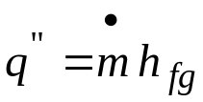
Exit Fluid Velocity: u = (dm/dt)/ρ
Darcy’s Law: 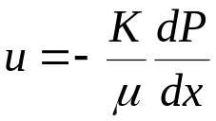

Property | V/ Li System | SiC/LiPb System
H_{fg} (MJ/Kg)  Ionization Energy | 19.6  (3.06 eV/atom= 48.8 MJ/ Kg) | 0.862
Viscosity (Ns/m2) | 0.003675 | 0.0147
ΔX (m) | 0.003 | 0.003
Density (Kg/m³) | 495 | 9200
PPI | 120 | 120
Permeability (m²) | 1.16E-08 | 1.16E-08
Fractional Density | 0.25 | 0.25
Diameter (m) | 0.000212 | 0.000212
Evaporation Rate (Kg/s) | 51 (without Ionization)  15 (with Li Ionization) | 1160
Pressure Drop (Pa) | 0.11 | 1.05
Exit Velocity (cm/s) | 1.03E-02 | 1.26E-02

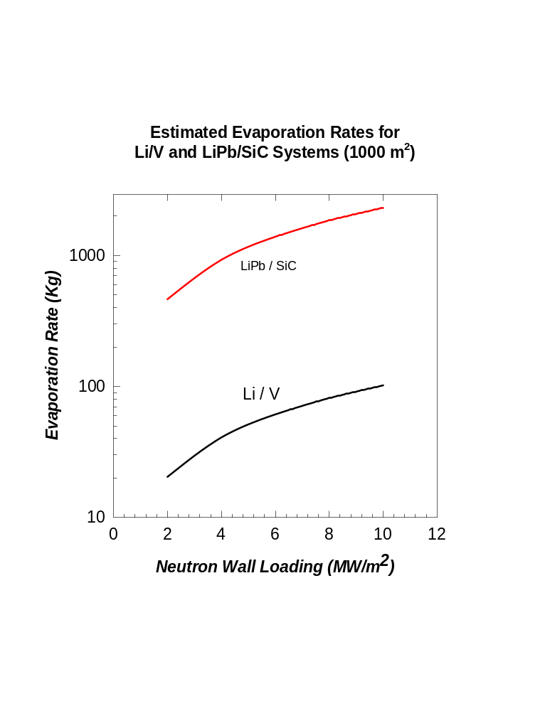
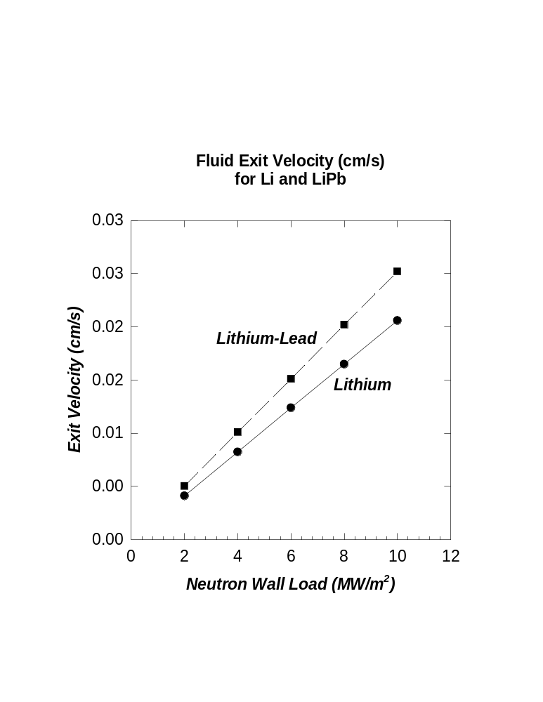
Possible Cycle

Plasma
Pump
Li Plasma
Recombination
Condensation
Magnetic Shear
FW
Blanket
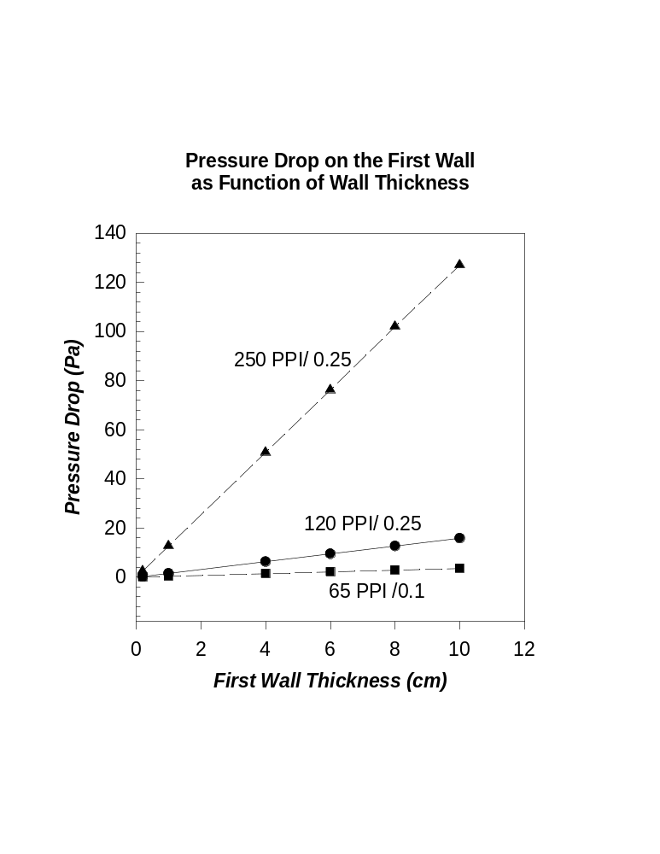

MANUFACTURING OF STRUCTURAL FOAMS

- Form Vapor Pre-cursors
- Transport to Polyurethane Substrate
- Pyrolize Polyurethane and form a thin graphitic skeleton structure
- Cause Reaction/ Deposition of desired elements on the graphitic skeleton
- Exhaust Reaction Products
- Vanadium is deposited from the thermal decomposition of its iodide
- The iodide is vaporized in vacuum at 700 – 1000 ºC
- Vanadium diiodide can be prepared from either vanadium carbide or a vanadium metal sponge, prepared by reducing VCl4 or VCl2 with magnesium.

FOAM MECHANICAL BEHAVIOR

COMPRESSION
Linear Elastic
Ductile
Brittle
BUCKLING
PLASTIC COLLAPSE
BRITTLE CRUSHING
SHEAR FAULTING

TENSION
Linear Elastic
Ductile
Brittle
CELL ROTATION & ALIGNMENT
BENDING & TENSILE FAILURE
MACRO & MICRO CRACK LINKAGE
FRACTURE TOUGHNESS
K_{IC} = 0.65 K_{ICs} *(ρ*/ρ)^{3/2}

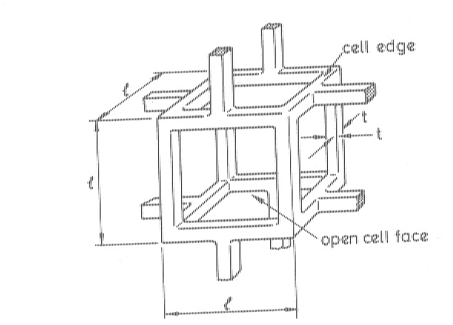
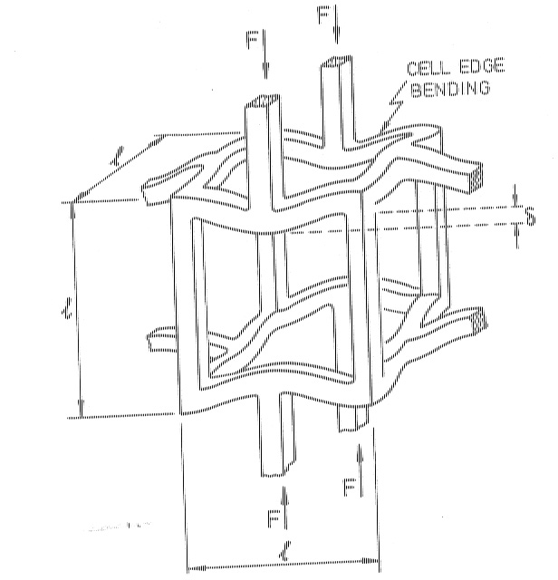
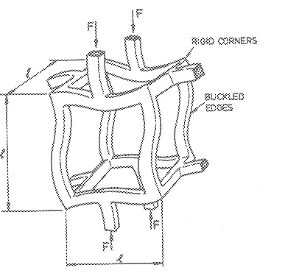
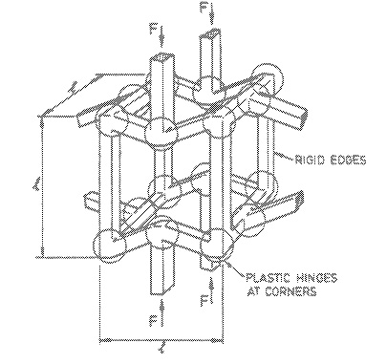
POSSIBLE FAILURE MODES IN CELLULAR FOAM STRUCTURES

(a) Un-deformed Shape (b) Bending-Type Deformation

(c) Plastic Hinge Failure (d) Buckling-type Failure

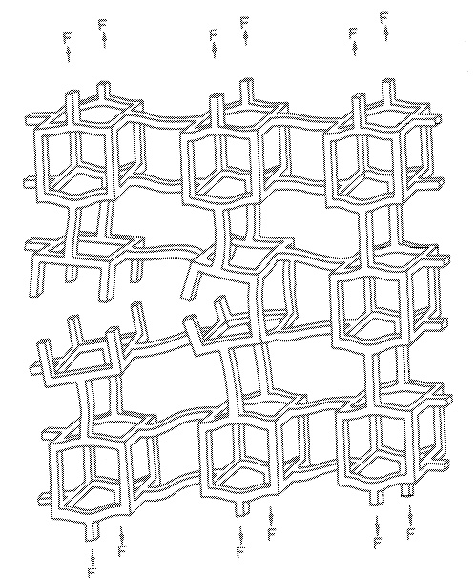Crack Propagation in Brittle Cellular Solids
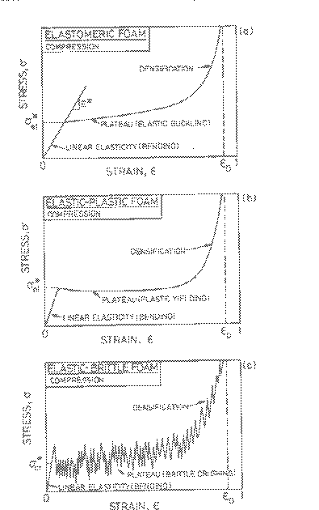
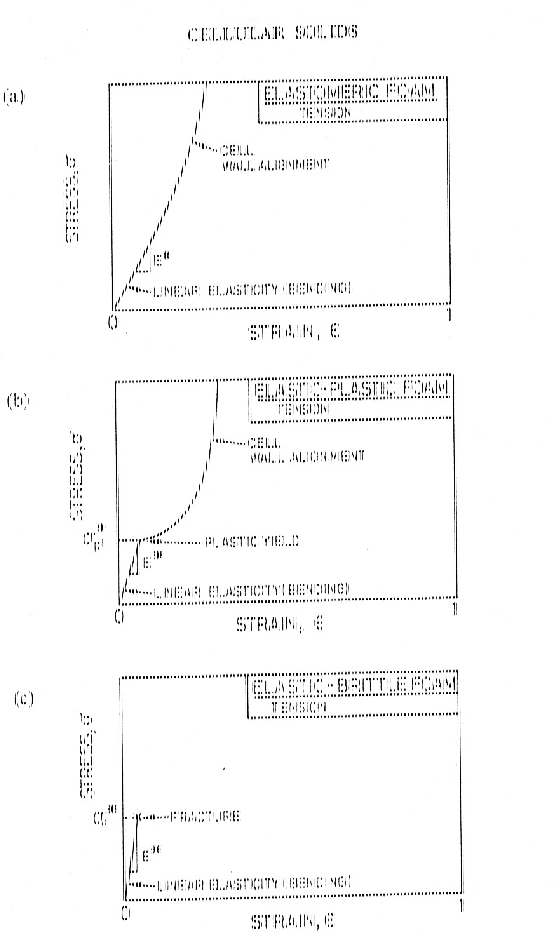
Stress-Strain Behavior in Compression Stress-Strain Behavior in Tension
SCALING RELATIONSHIPS FOR MECHANICAL PROPERTIES
- Elastic Constants: Let the fractional density be 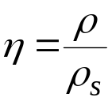
E = C₁ E_{s} η² G = C₂ G_{s} η² , C₁ ≅ 1, C2 ≅ 3/8, 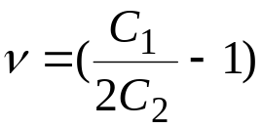

- Densification Strain:
ε_{D} = 1 – 1.4 η
- Plastic Collapse Strength (Metals):
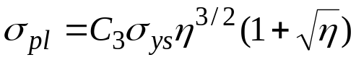

- Brittle Crushing Strength (Ceramics):
, C₄ ≅ 0.65
, Y = Geometry factor, K_{ICs}= solid fracture strength, a= flaw size
- Fluid Effects: Internal Fluids will add another contribution to the strength due to “ side-squeezing” effects.

C = Constant, μ= viscosity, ε = strain, 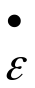= strain rate, L = FW thickness, l = pore size.
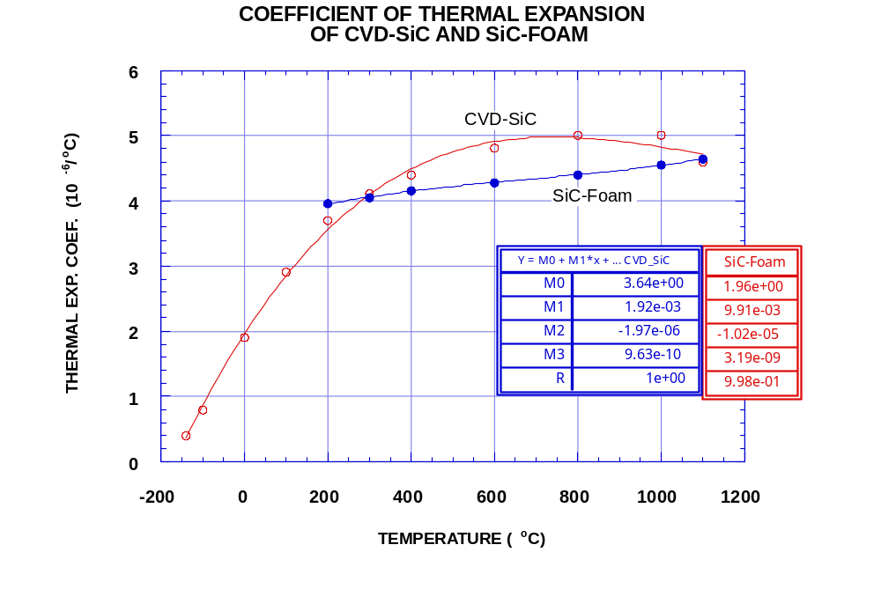
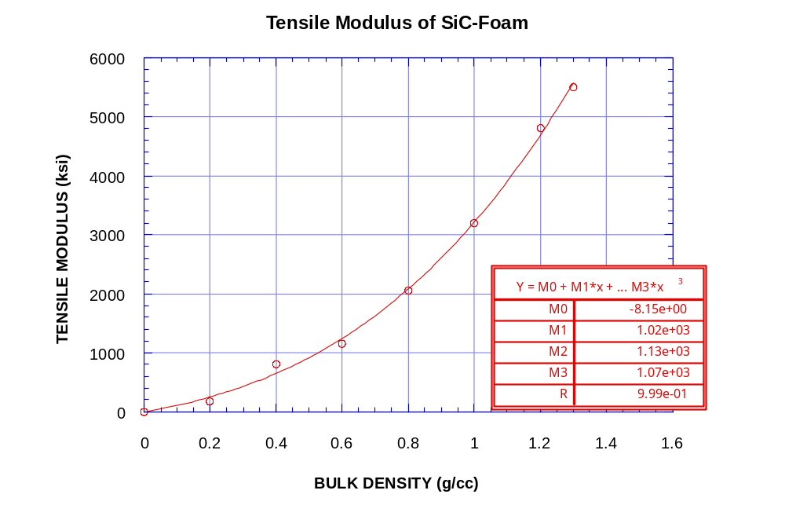
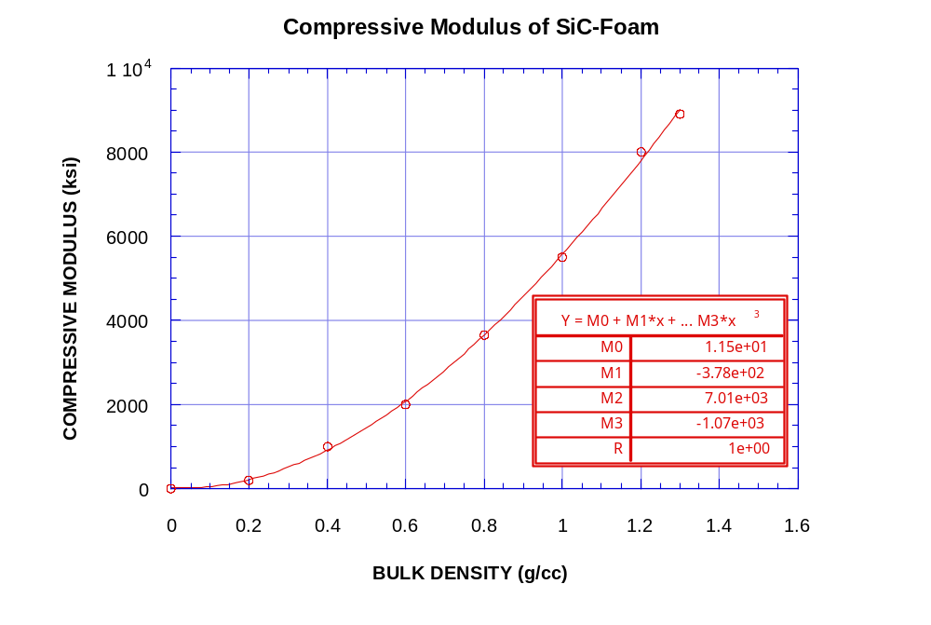
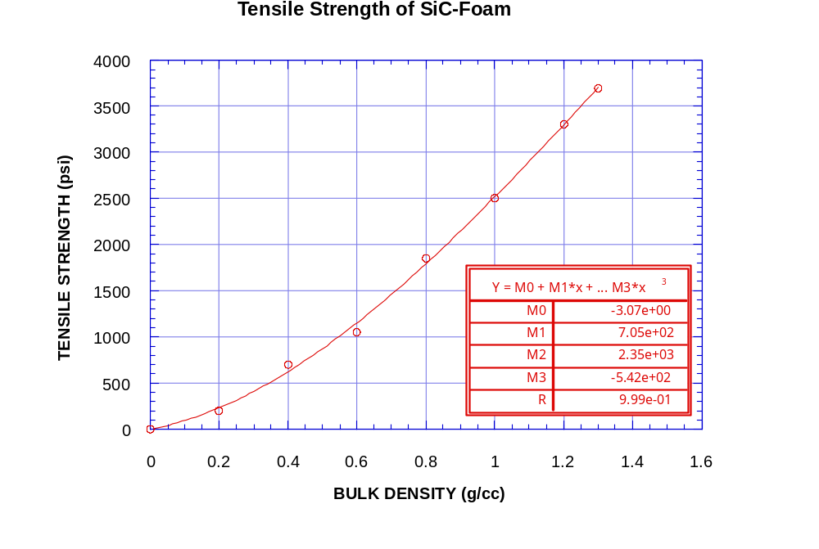
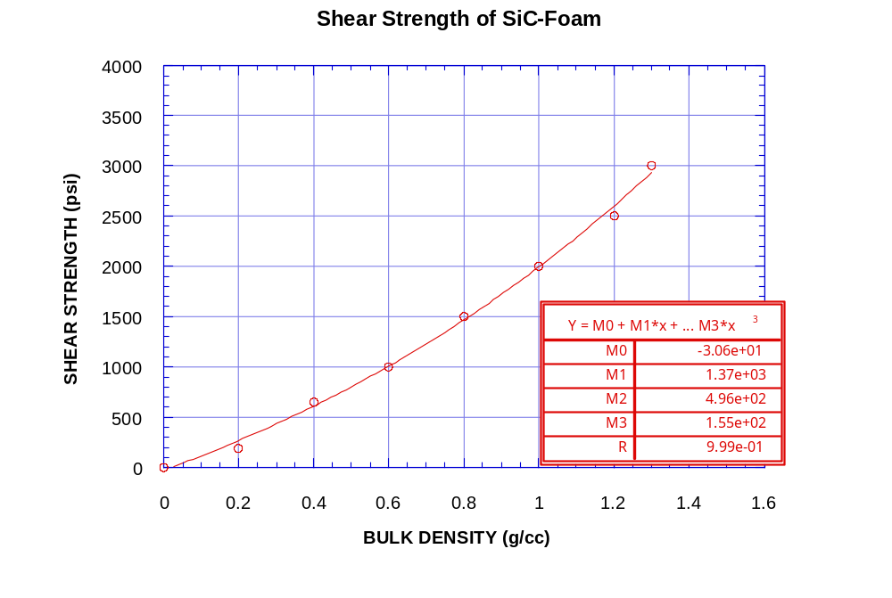
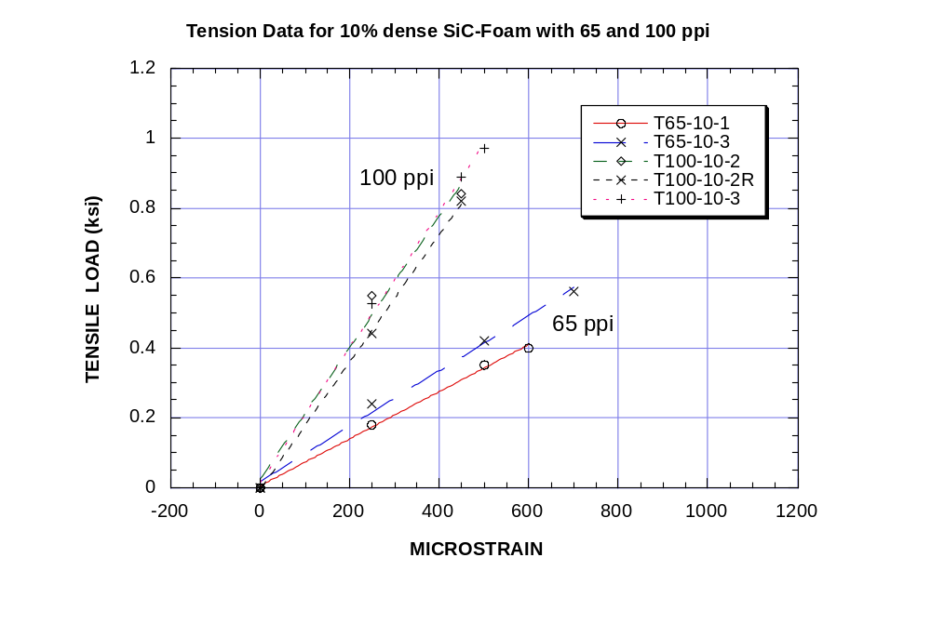
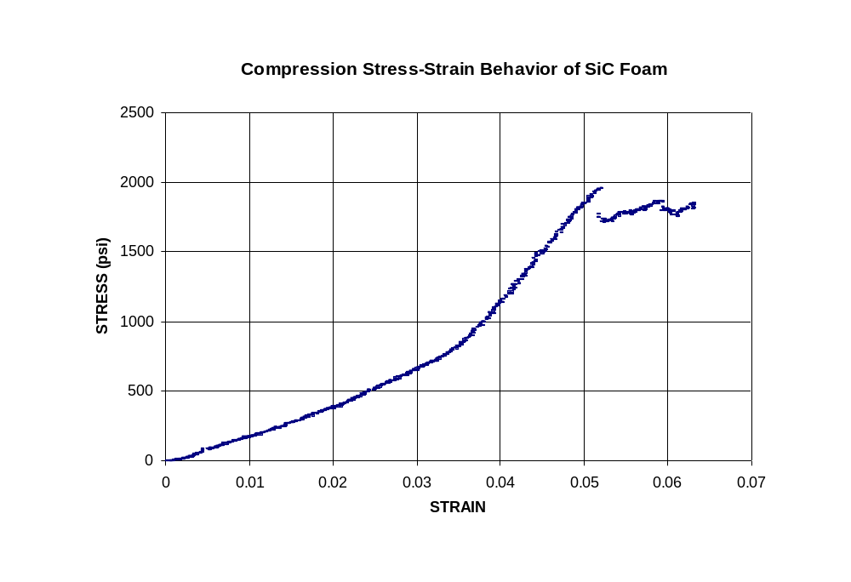

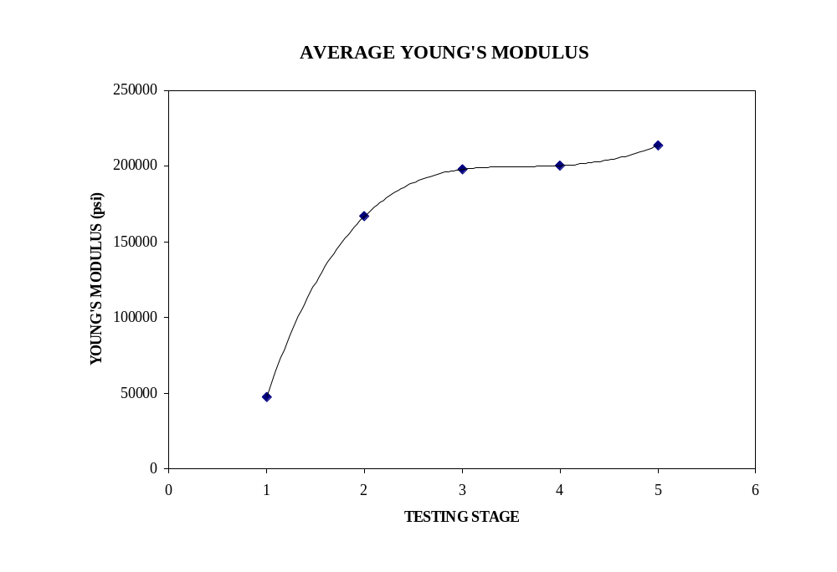

CONCLUSIONS
- Utilization of a Foam/ liquid/ vapor system in first wall cooling seems to be feasible for high power density operation.
- The large energy stored in h_{fg} can be used in an evaporation/ condensation cycle.
- Condensation on a liquid metal divertor requires recycling of about 50 Kg/s for the entire reactor.
- Numerous advantages may be possible with our system: low-pressure drops (including MHD), high temperature limits for first wall operation, high power density.
- Limitations on power density will be determined by plasma physics and Li vapor pumping requirements.

